# Chrome_TC_01:Purchase Order

### Orient LED Login Page.

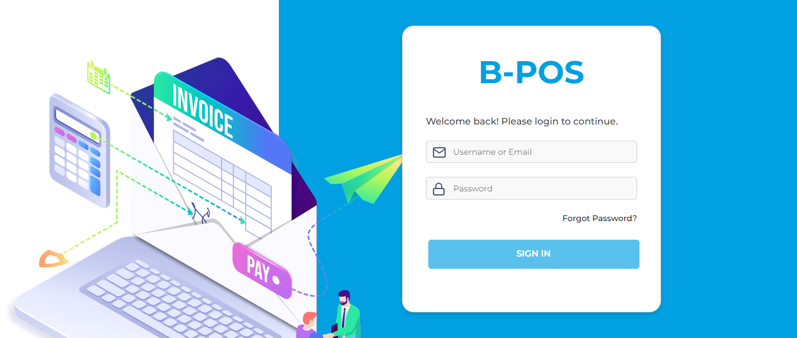

### The Home page with lot of navigation options to navigate different modules and serving as the entry point to the website.

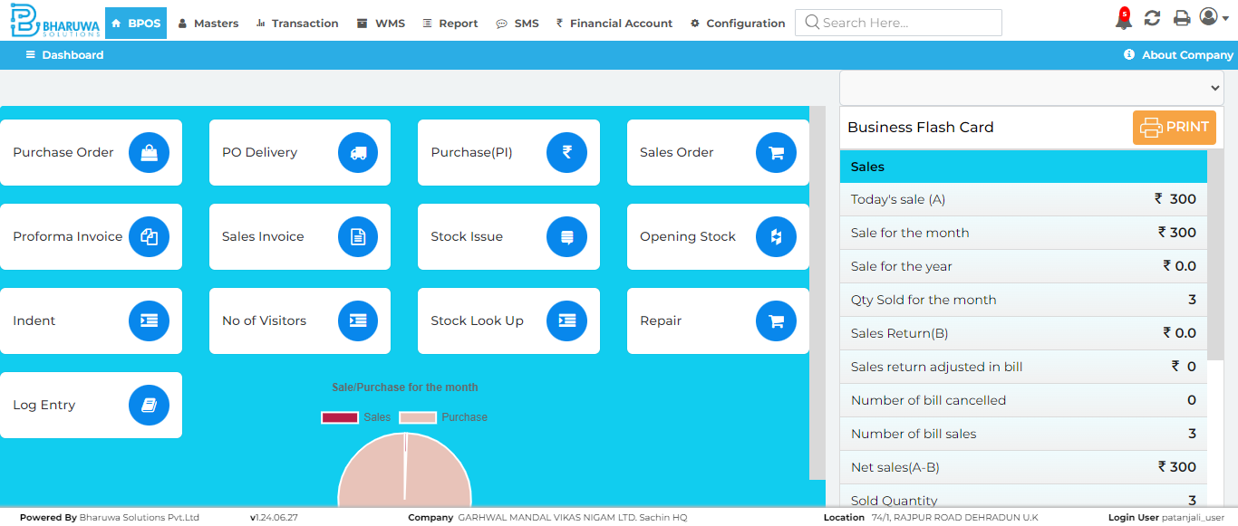

### Transaction module with lot of sub-modules to perform vairous transactinos for user.

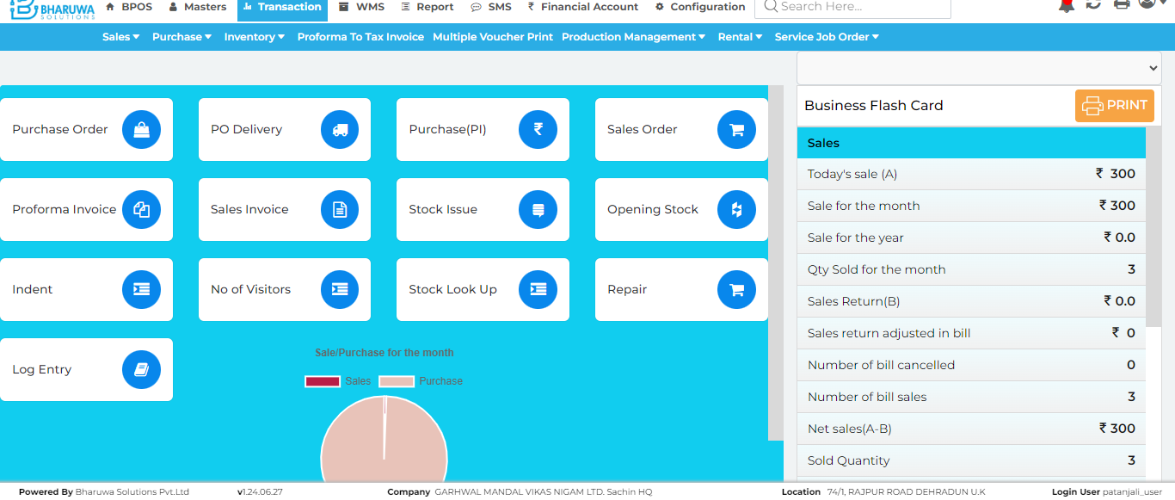

### Purchase order screen, where user can raise purchase orders for preferred suppliers.

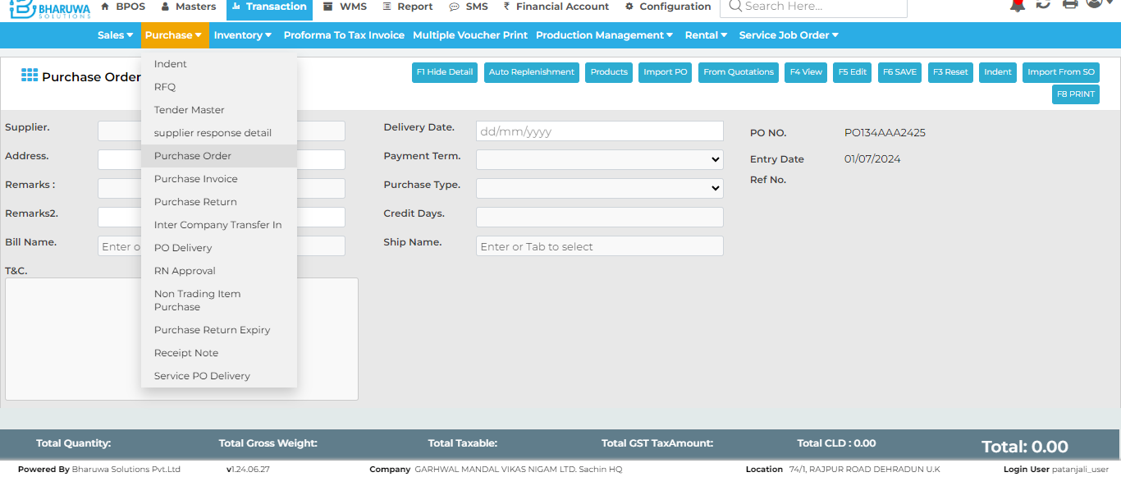

### Suppliers modal window which lists all available suppliers.

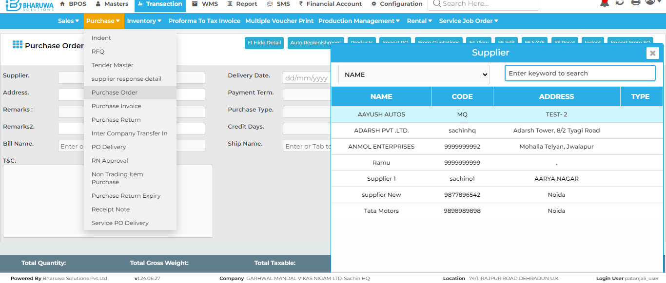

### Successfully created Purchase Order with selected supplier for preferred items.

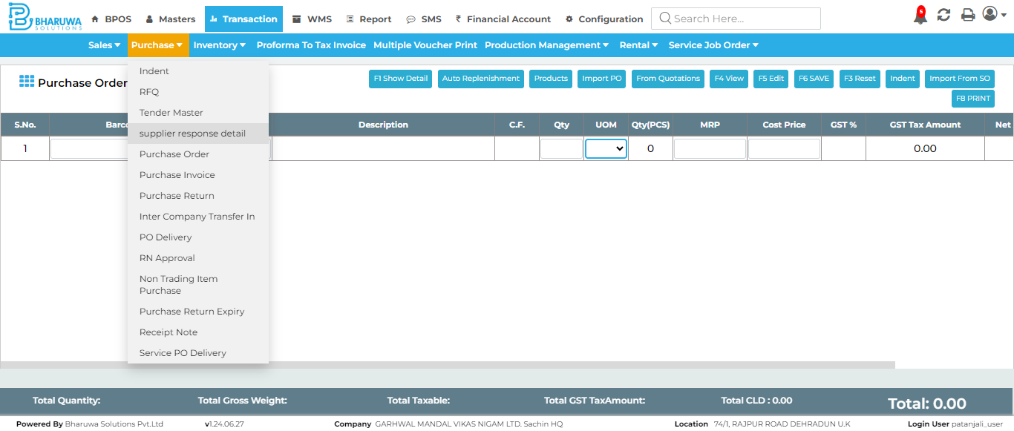

#### TC_01 - TEST PASSED